Week 1
Question 1: Discuss the process by which Python executes a program, focusing on the stages involved from source code to execution.
Python is an interpreted, high-level programming language, but internally it follows a multi-stage execution process. From writing the source code to displaying the final output, Python passes through several important stages to ensure correct and efficient execution.

1. Writing the Source Code
The execution process begins when the programmer writes a Python program using a text editor (such as Notepad) or an Integrated Development Environment (IDE) like PyCharm, VS Code, or IDLE.
- The program is written using Python’s syntax and rules.
- The source code is saved with a .py extension, which identifies it as a Python file.
- At this stage, the code is human-readable and cannot be executed directly by the computer.

2. Lexical Analysis and Syntax Checking
Before execution, Python performs lexical analysis and syntax checking.
- The Python interpreter scans the source code line by line.
- It checks for syntax errors, such as:
  - Missing colons
  - Incorrect indentation
  - Misspelled keywords
- If a syntax error is detected, execution stops immediately, and Python displays an error message indicating the location and type of error.
Only when the program is syntactically correct does Python proceed to the next stage.

3. Compilation into Bytecode
Once the code passes syntax checking, Python compiles the source code into bytecode.
- Bytecode is an intermediate, low-level representation of the program.
- It is platform independent, meaning the same bytecode can run on different operating systems.
- The bytecode is stored temporarily in a .pyc file, usually inside a __pycache__ directory.
- This step improves performance because Python can reuse bytecode instead of recompiling the source code every time.
Unlike traditional compilers, Python does not compile directly to machine code.

4. Execution by Python Virtual Machine (PVM)
The Python Virtual Machine (PVM) is the core component responsible for executing Python programs.
- The PVM reads the bytecode instruction by instruction.
- It interprets each instruction and determines the appropriate action.
- The PVM handles memory management, function calls, and object creation.
- This is why Python is often described as an interpreted language, even though compilation to bytecode occurs first.

5. Machine-Level Execution
At this stage, the PVM translates bytecode instructions into machine-level operations.
- These operations are understood by the computer’s processor (CPU).
- The hardware executes the instructions step by step.
- Arithmetic calculations, logical comparisons, and control flow operations occur here.
Although Python itself does not generate machine code directly, this stage bridges the gap between bytecode and actual hardware execution.

6. Output Display
After successful execution of all instructions:
- The results of the program are produced.
- Output may be:
  - Displayed on the screen using print()
  - Written to a file
  - Stored in memory or variables
- If runtime errors occur (such as division by zero or accessing undefined variables), Python stops execution and displays an error message.

Flow: Python Program Execution Process

Source Code (.py)
↓
Syntax Checking
↓
Compilation to Bytecode (.pyc)
↓
Python Virtual Machine (PVM)
↓
Machine-Level Instructions
↓
Program Execution
↓
Output Displayed
Question 2: Discuss the fundamental features of the Python programming language that make it widely used for modern software development.
Introduction
Python is a high-level, general-purpose programming language that has gained widespread popularity in modern software development. Its simplicity, flexibility, and powerful built-in features allow developers to build applications quickly and efficiently. Python supports multiple programming paradigms and is widely used in areas such as web development, data science, artificial intelligence, automation, and scientific computing.

Fundamental Features of Python
1. Simple and Readable Syntax
Python is known for its clean and easy-to-read syntax.
- Its code structure closely resembles the English language.
- It uses indentation instead of braces, which improves code readability.
- Fewer lines of code are required compared to many other languages.
This simplicity makes Python ideal for beginners while also improving productivity for experienced developers.

2. Interpreted Language
Python is an interpreted language, meaning programs are executed line by line.
- This allows programmers to test and debug code easily.
- Errors are detected at runtime, making troubleshooting simpler.
- No separate compilation step is required, which speeds up development.

3. Platform Independence
Python is a platform-independent language.
- The same Python program can run on Windows, Linux, and macOS.
- This is possible because Python code is executed by the Python interpreter rather than directly by the operating system.
- Platform independence reduces development and maintenance effort.

4. Object-Oriented Programming (OOP) Support
Python fully supports object-oriented programming concepts.
- It allows the creation of classes and objects.
- Supports inheritance, encapsulation, and polymorphism.
- Helps in organizing large programs into reusable and maintainable components.
OOP support makes Python suitable for building large-scale software systems.

5. Large Standard Library
Python comes with an extensive standard library.
- Includes modules for file handling, database connectivity, networking, and web development.
- Supports advanced domains such as data science, machine learning, artificial intelligence, and automation.
- Reduces the need to write code from scratch, saving time and effort.

6. Open Source and Free
Python is an open-source language and is freely available.
- Anyone can download, use, and modify Python without licensing costs.
- A large global community contributes libraries, frameworks, and tools.
- Continuous updates and improvements keep the language modern and reliable.

Conclusion
Python’s simple syntax, interpreted nature, platform independence, object-oriented support, rich standard library, and open-source availability make it one of the most widely used programming languages today. These features enable rapid development, easy maintenance, and scalability, making Python a preferred choice for modern software development across multiple domains.

Question 3: Install IDLE interpreter for Python programming by following the steps mentioned below.
Introduction
IDLE (Integrated Development and Learning Environment) is the default Python IDE. It allows users to write, edit, and execute Python programs easily.
Steps to Install IDLE
- Open a web browser and visit the official Python website:
https://www.python.org
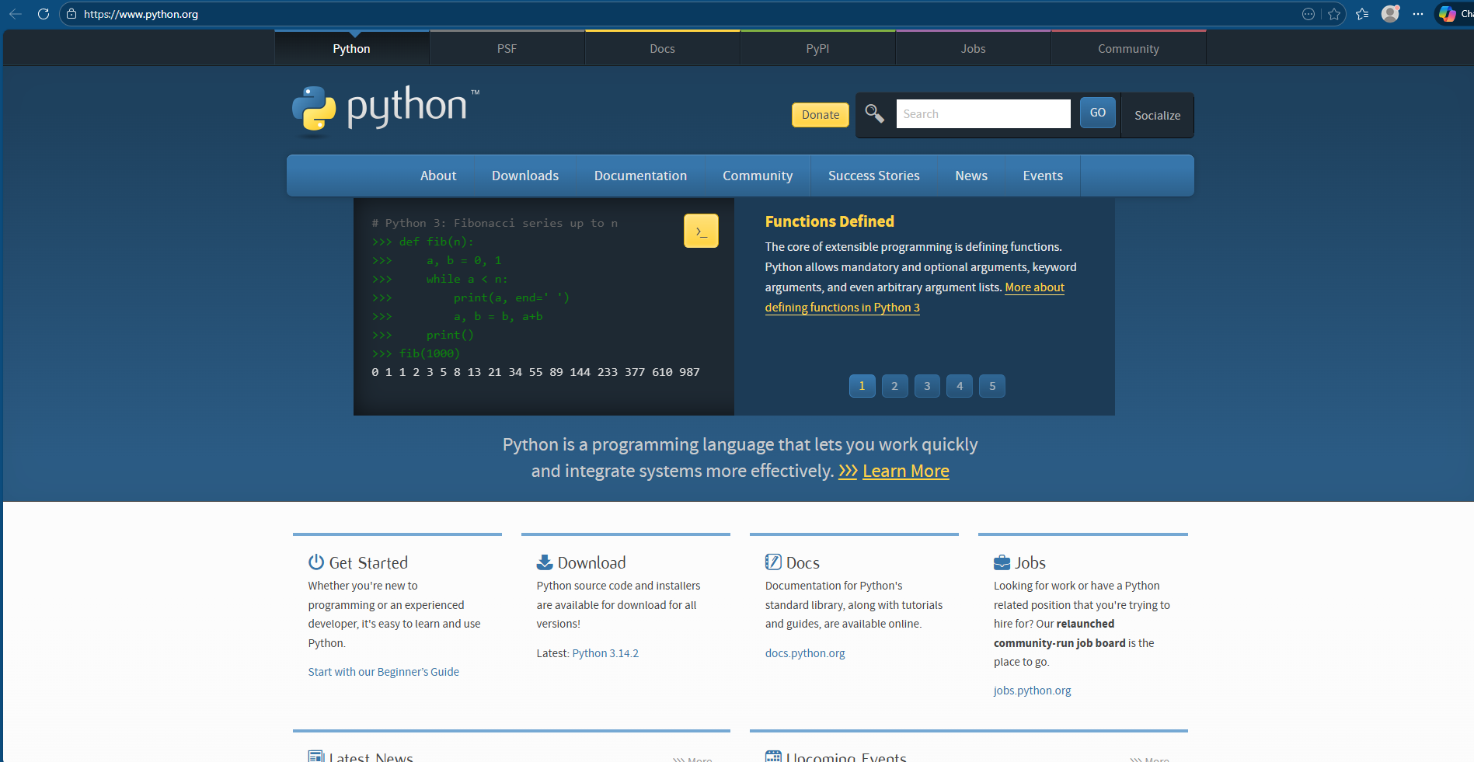
- Click on the Downloads section and select the appropriate version for your operating system.
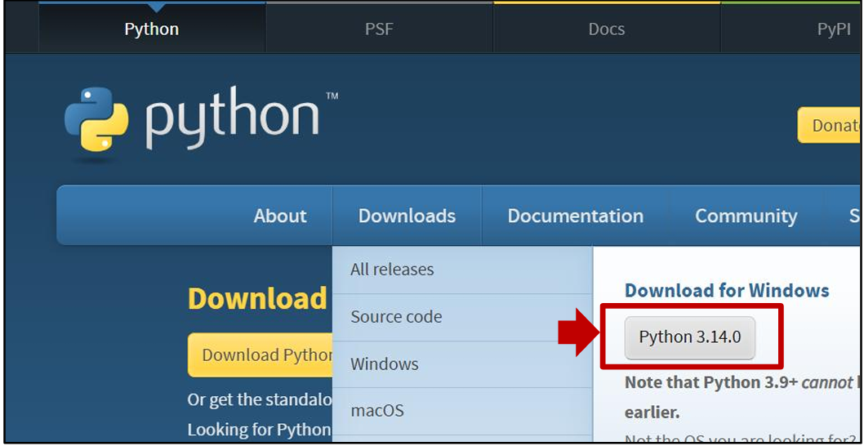
- Download the installer file.
- Run the installer by double-clicking the file.
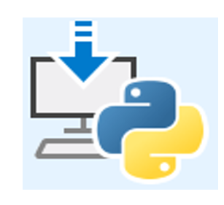

- Select the option “Add Python to PATH” to enable command-line execution.
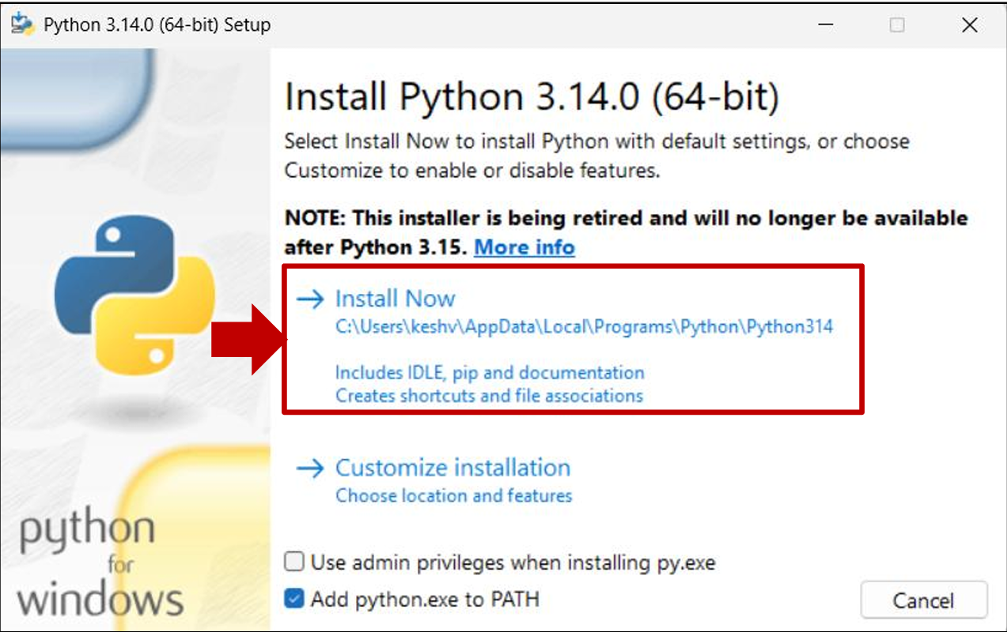
- Click Install Now and wait for the installation to complete.
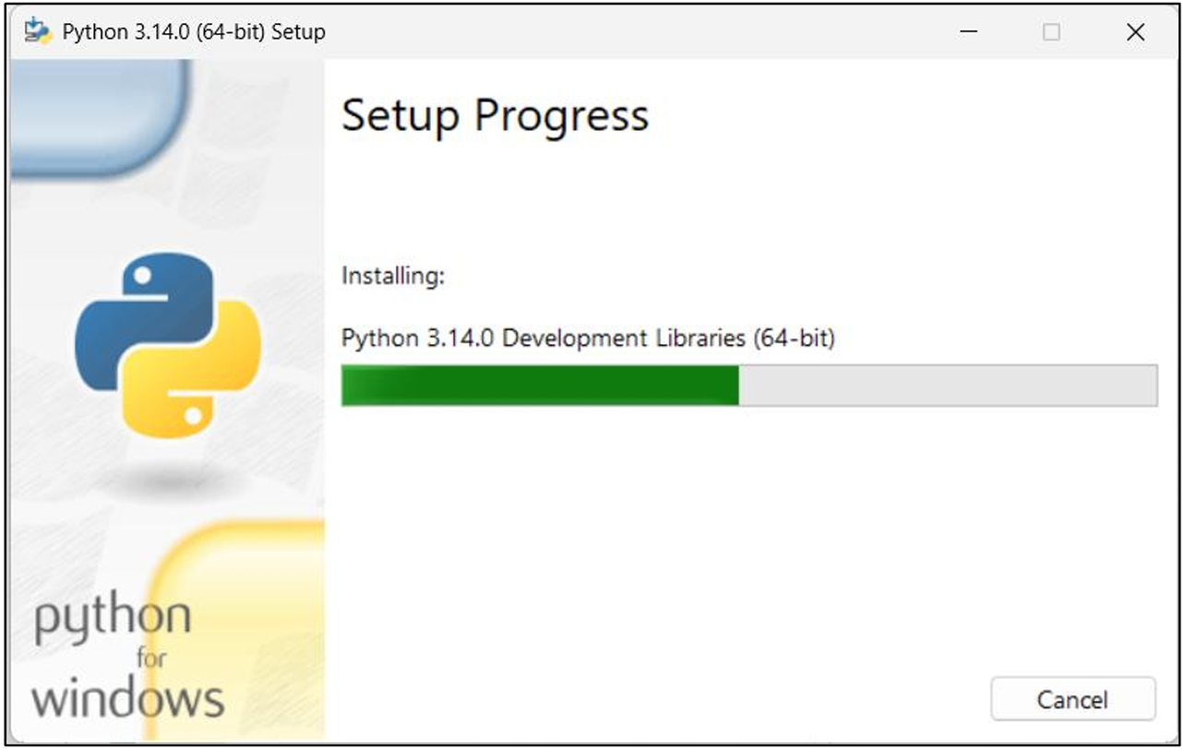
- After installation, open IDLE (Python GUI) from the Start Menu.
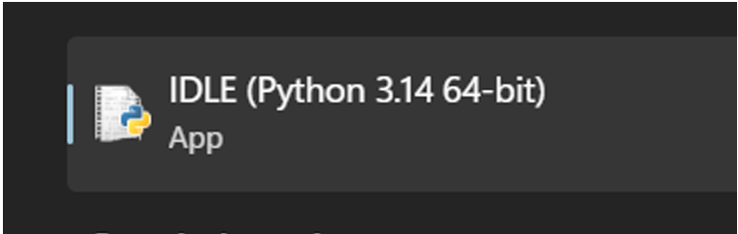
- Open and Use
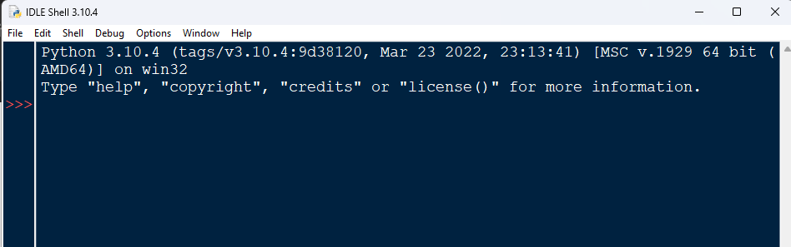

Week 2
1# Use interactive Shell to print:
• User said "Great app!"
• C:\new_folder\test\
Code:
print("User said \"Great app!\"\nC:\\new_folder\\test\\")
Screenshot:
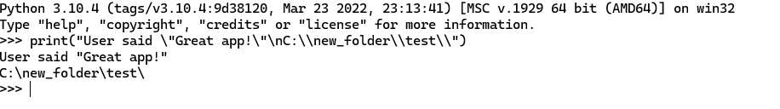
2# A shopkeeper uses Python shell for quick billing calculations.
Code:
a = int(input("Enter a number : "))
b = int(input("Enter another number : "))
op = input("Enter the operator : ")

if op == '+':
print(a+b)
elif op == '-':
print(a-b)
elif op == '*':
print(a*b)
elif op == '/':
print(a/b)
else :
print("Invalid Operator ")
Screenshot:
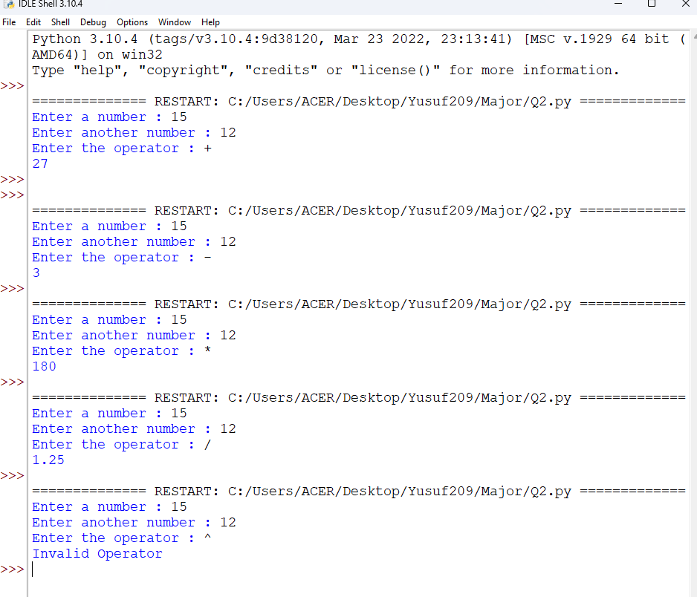
3# A college form stores student names. Create variables firstName and lastName with your own names.
Code:
firstName = input("Enter your first name: ")
lastName = input("Enter your last name: ")
Screenshot:
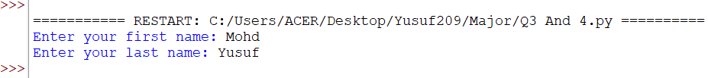

4# Print firstName and lastName in single line. (use f"") (Try: print(firstName, lastName)
Code:
firstName = input("Enter your first name: ")
lastName = input("Enter your last name: ")

print(f"{firstName} {lastName}")
print(firstName,lastName)
Screenshot:
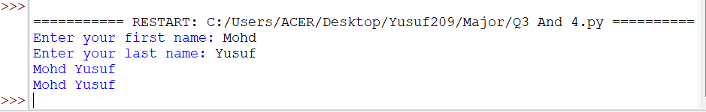
5# A heritage museum kiosk needs an automated display-and-billing script. Create a single Python file kioskSystem.py that performs the following:
i) Billing Module: The museum café calculates totals for simple arithmetic checks.
ii) Information Display Module: After billing output, print two separate informational messages for visitors:
• "Welcome to the National Art Museum
• "Digital exhibits were introduced in 2015"
Code:
a = int(input("Enter a number : "))
b = int(input("Enter another number : "))
op = input("Enter the operator : ")

if op == '+':
print(a+b)
elif op == '-':
print(a-b)
elif op == '*':
print(a*b)
elif op == '/':
print(a/b)
elif op == '%':
print(a%b)
else :
print("Invalid Operator ")
print("Welcome to the National Art Museum ")
print("Digital exhibits were introduced in 2015")
Screenshot:

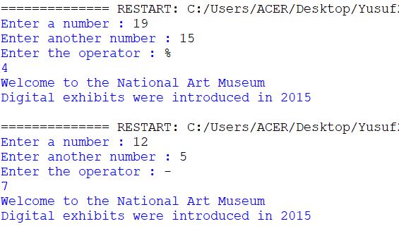

6# An engineer calculates load using a polynomial. Given a=3, b=-2, c=6, d=1, e=4, f=7 and input x,
Compute: ax5 + bx4+ cx3 + dx2 + ex + f1/2
Code:
a=3
b=-2
c=6
d=1
e=4
f=7
x = int(input("Enter the value of x"))
res = a*x**5 + b*x**4+ c*x**3 + d*x**2 + e*x + f**(1/2)
print("Result = ",res)
Screenshot:
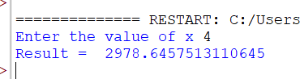

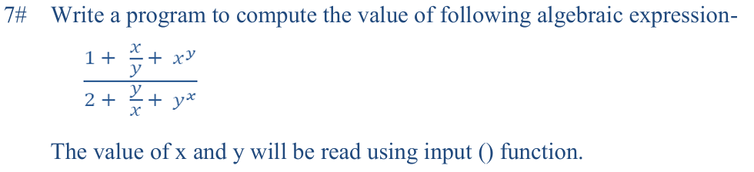
Code:
x = float(input("Enter the value of x: "))
y = float(input("Enter the value of y: "))

numerator = 1 + (x / y) + (x ** y)
denominator = 2 + (y / x) + (y ** x)
result = numerator / denominator
print("Result =", result)
Screenshot:
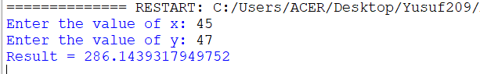

8# A technician optimizes multiplication using bitwise operations. Read an integer and multiply it by 2 using <<
Code:
n = int(input("Enter an integer: "))
result = n << 1
print("Result =", result)
Screenshot:
